GitHub URL
https://github.com/wesleyhixon/Programming-Assignments/tree/5b28ed5f585fbc1d25c4aafa5bd481a1fa4215d5/CSCI%20202/M08%20Final%20Project

1. Readme Documentation
This project is a C++ implementation of the game Wordle, designed to emphasize clean object-oriented design and separation of responsibilities. The program accepts user guesses and commands via a text-based interface, validates guesses against a dictionary, and generates color-coded hints using a frequency-map-based algorithm to correctly handle duplicate letters. The codebase is organized into focused components for input handling, game state management, hint evaluation, and rendering, making the system easy to extend and maintain. This project was created as a learning exercise in software design, data structures, and algorithmic reasoning.

2 Test Case and Results

Use Case | Test Case | Result | Meets Specification
Only five letter words in the dictionary must be accepted | Input = "candle" (not present in dictionary, 6 letters long) | Guess rejected; error message displayed; guess not counted | ✓
Only five letter words in the dictionary must be accepted | Input = "apple" (present in dictionary, 5 letters long) | Guess accepted; hints displayed | ✓
6 guesses are allowed | 6th guess; answer = "covet"; input = "apple" | Guess rejected; answer displayed; game over | ✓
Commands such as "help" or "exit" are accepted | Input = "help" | Input is recognized as command; Help menu detailing commands is displayed | ✓

3 Algorithm Analysis
My hint checking algorithm takes in a guess and an answer and returns the colored hint of each index in the guess. To do this it has to first produce a frequency map which associates each character with the number of times it appears in the answer. The efficiency of this algorithm as a linear scan is O(n).
Then, my algorithm marks the letters which match their position in the answer as being colored green. To do this it iterates over the guess and checks against the same index in the answer. If they are equal, it marks that index as green and subtracts that character from the frequency map to mark it as “used”. Iterating over the guess is O(n) and accessing the map is average O(1) which makes this algorithm O(n).
The last step is to mark the yellow hints in the guess. To do this, my algorithm iterates over the guess a second time. If the index is not marked as green, it checks if there remains an “unused” letter in the frequency map. If there is, it marks the space as yellow and subtracts from the frequency map. Iterating over the guess is O(n) and accessing the map is O(1) which makes O(n).
Overall, my algorithm has to iterate over the answer once and over the guess twice. Each of these is O(n) which makes O(3n) or O(n) in total. The efficiency of my algorithm scales linearly with length, but, since Wordle guesses have a fixed length, the efficiency is fixed.
In the best case scenario each letter matches the answer and the algorithm can exit early with all greens. This is still O(n) as you still have to compare each letter. In the worst case scenario at least one of the letters does not match and you must iterate over the guess twice. This means that best case is O(n), worst case is O(n), and average is O(n).

Lessons Learned
This project has taught me a lot about object oriented design and separation of responsibilities. My first iteration was a simple, mostly procedural program which used one large “Wordle” class. This class quickly became large and unwieldy and changing one feature meant affecting lots of different pieces of code. I realized that I should pivot to a more object oriented approach. I laid out the different responsibilities my code was fulfilling and split them into classes. This new design made adding new features effortless as it only required editing the objects that were involved in that pipeline. This project has shown me how easy development can be when you use object oriented design to properly separate different responsibilities. If I were to improve my project I would split my StateManager into a ProgramStateManager and a GameStateManager so I could create an instance of the GameStateManager for each game and simplify the classes. I think I will continue to improve my project a bit further and then package it into binaries to share easily. Next I may make another program with the object oriented design principles I’ve learned.

2 Flowchart Screen Shots
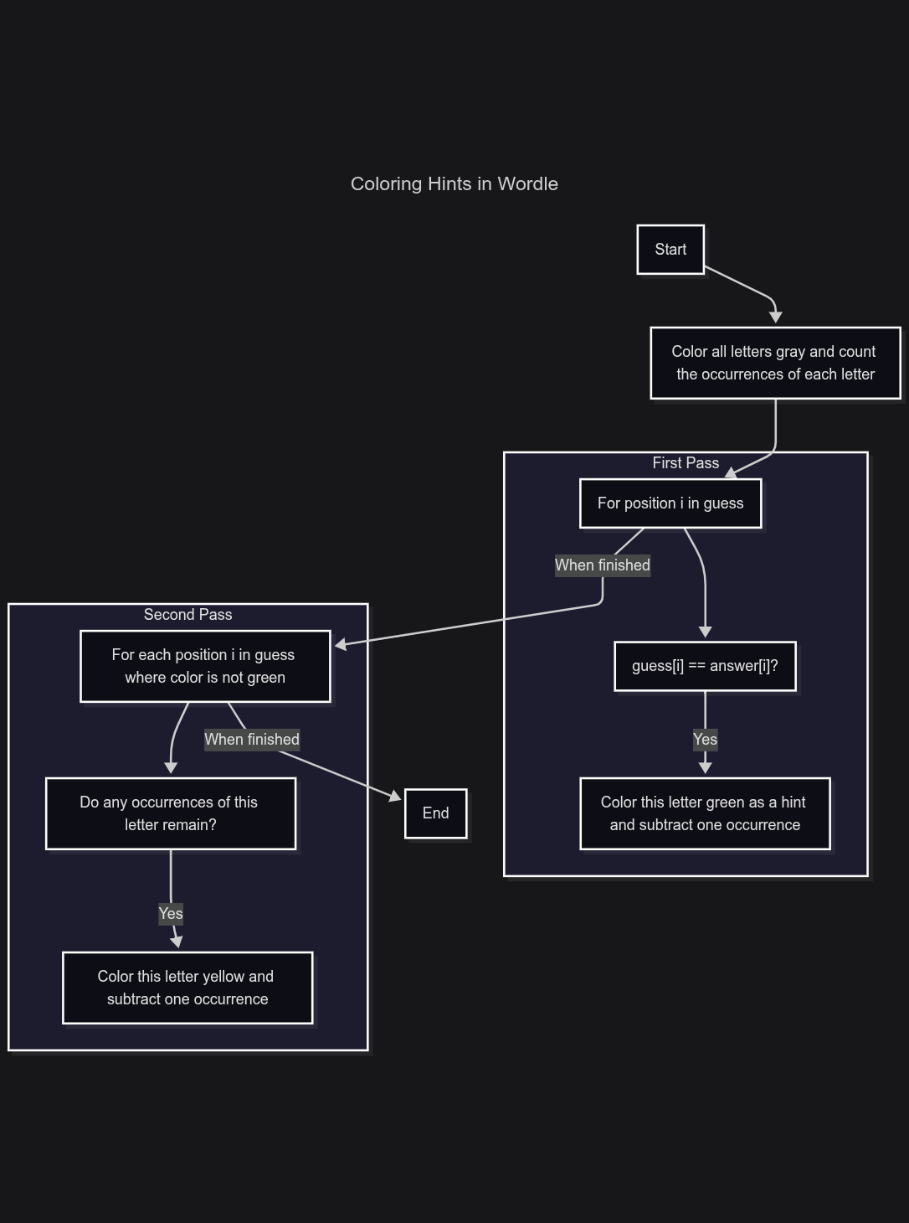

3 UML and Use Case Diagrams
High level class diagram
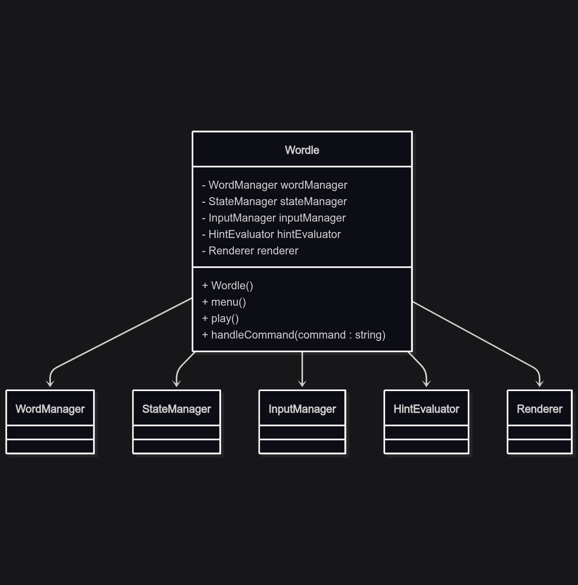

Hint evaluation pipeline
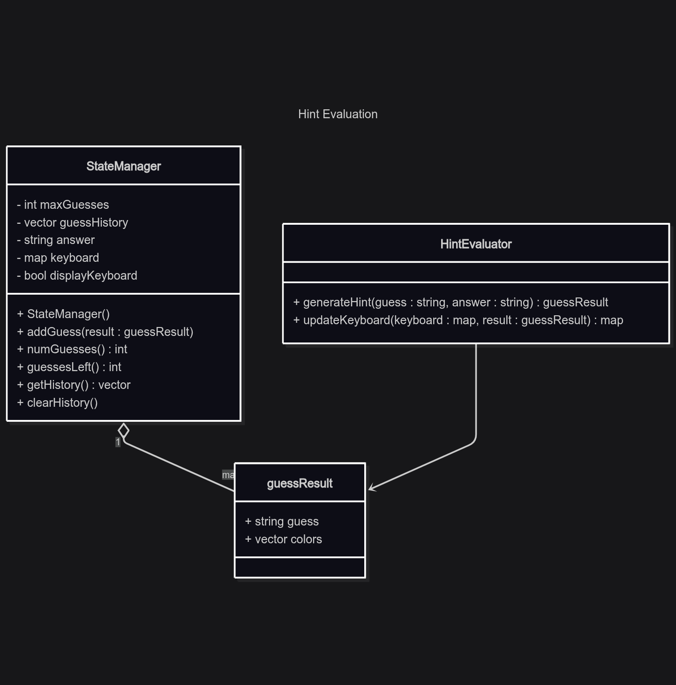
Input pipeline
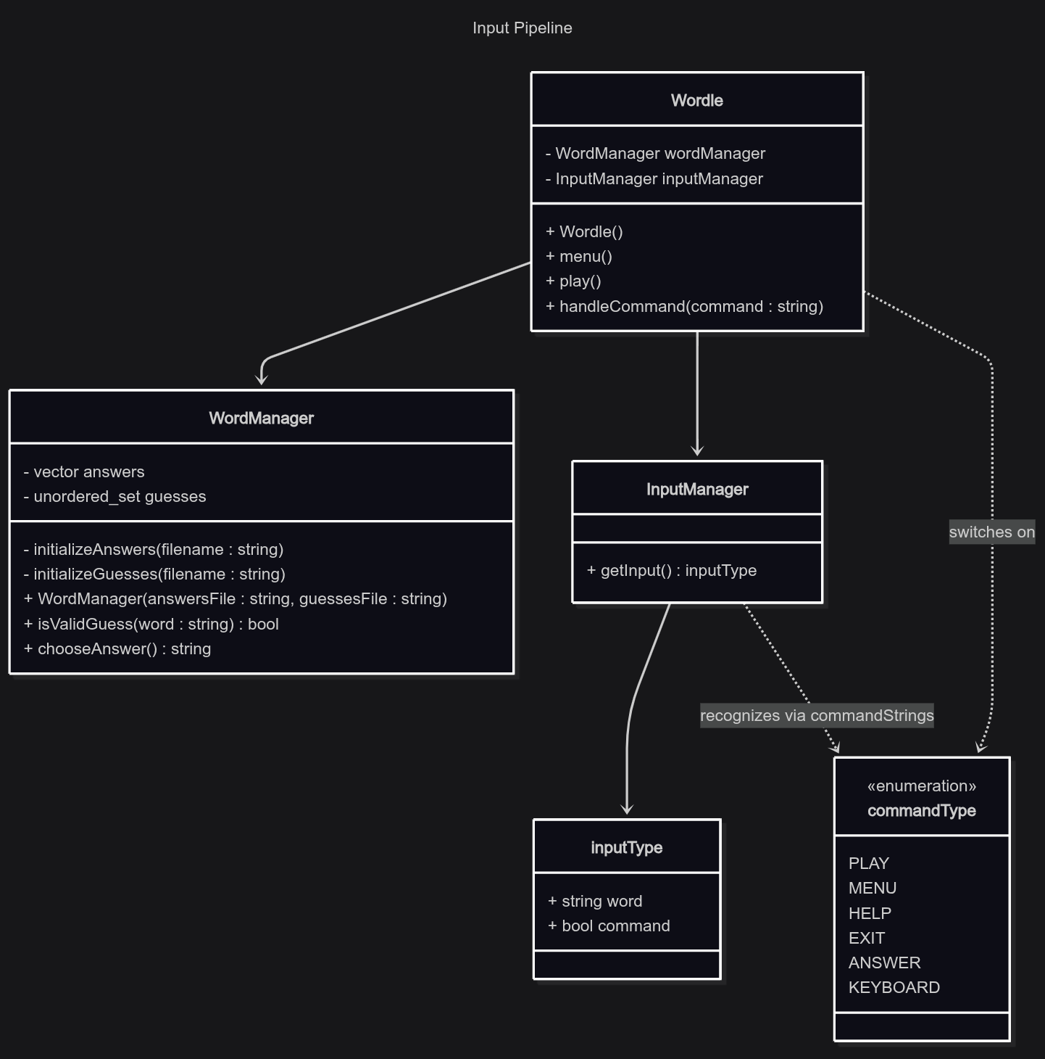
Use case diagram
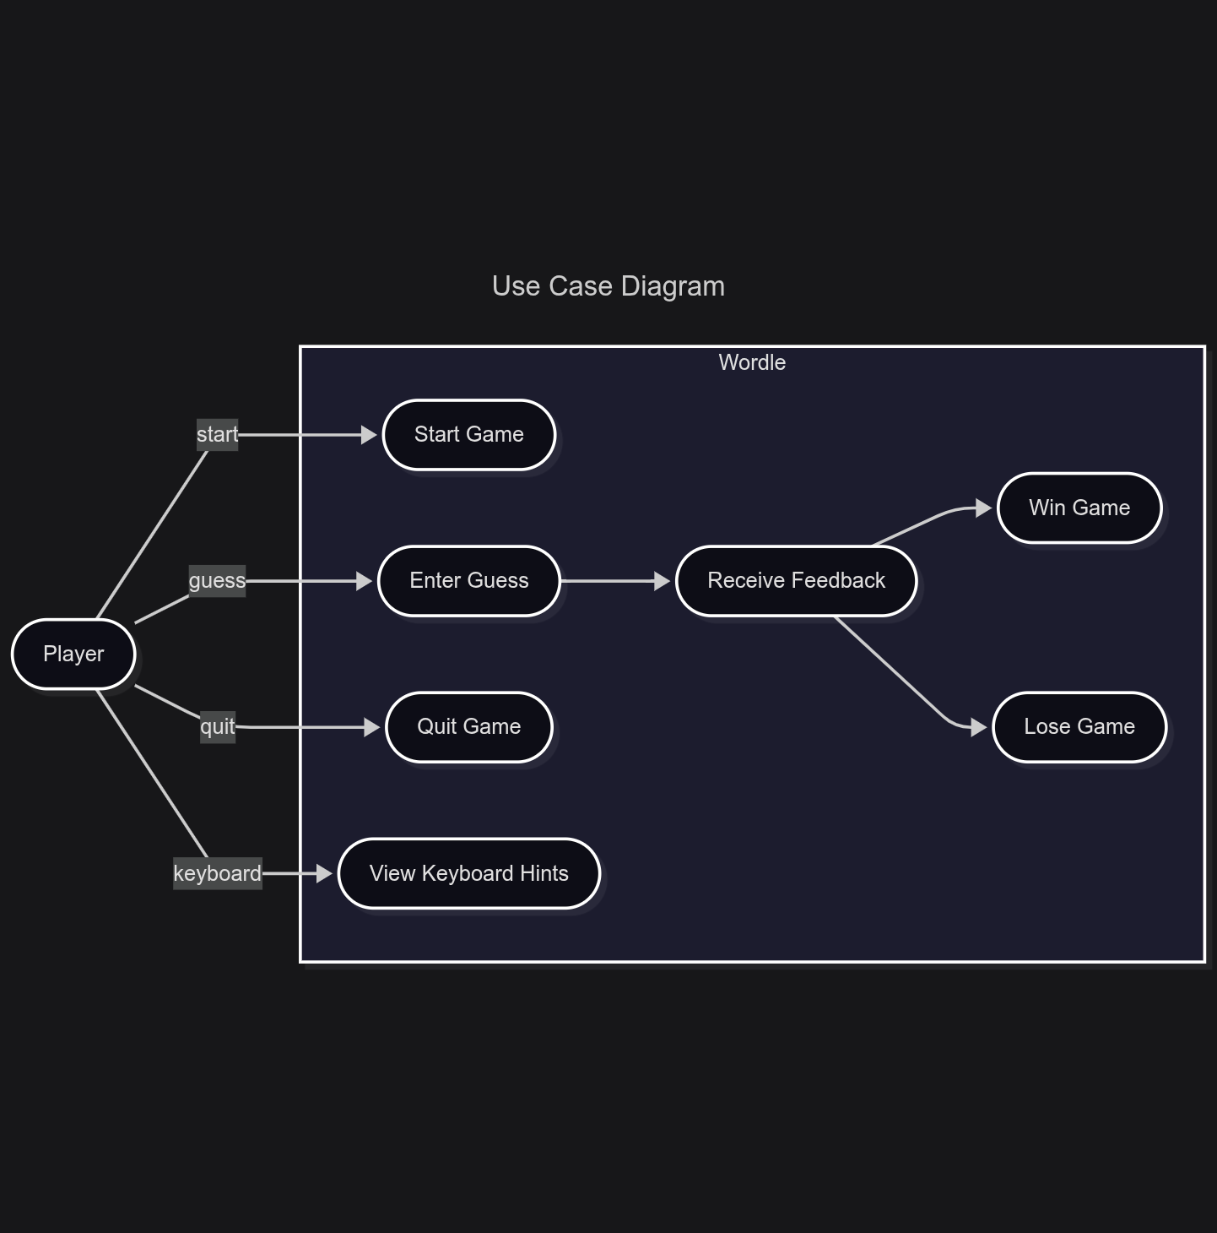

Full class diagram
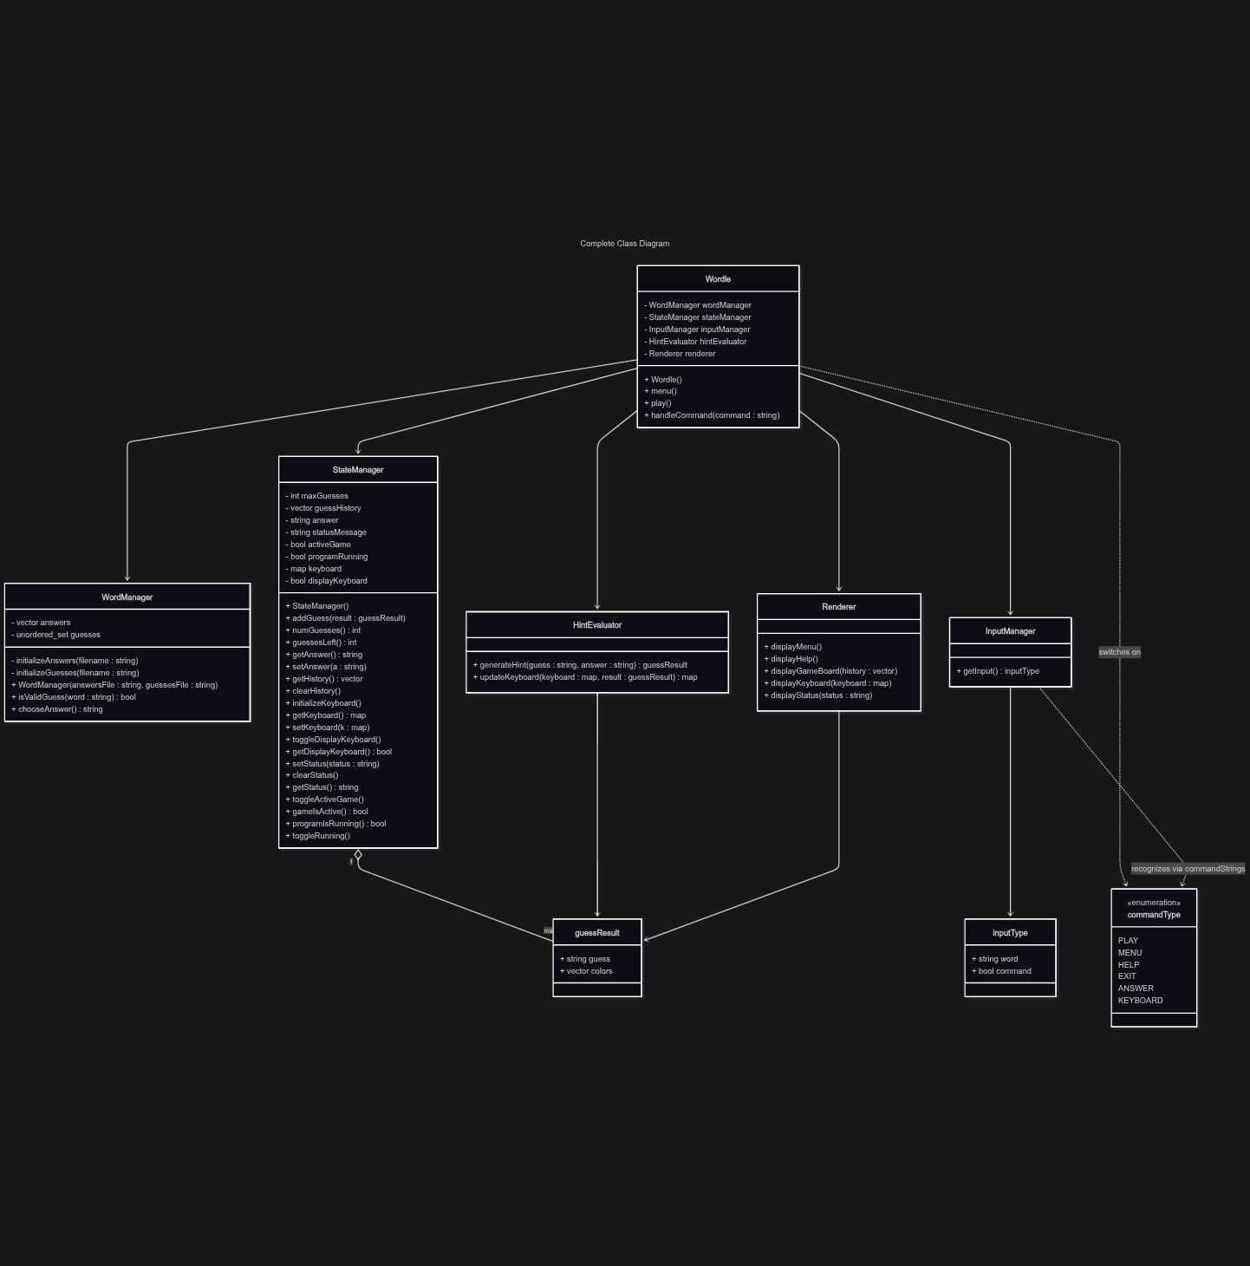

4 Source Code of All files (.h, .cpp)
#include <iostream>
#include <string>
#include <fstream>
#include <unordered_set>
#include <vector>
#include <exception>
#include <algorithm>
#include <map>
#include <unordered_map>
#include <fmt/core.h>
#include <fmt/base.h>
#include <fmt/color.h>

void clrscr();

/*
//todo add a keyboard
//- Finish adding displayKeyboard
//- add keyboard command to handleCommands()
todo add stats functionality
//todo create a main menu
*/

/*
Name: Wordle
Author: Wesley Hixon
Date Last Updated: 12/18/2025
Purpose: A fun Wordle game you can play in your command line!
*/

enum commandType{
PLAY, MENU, HELP, EXIT, ANSWER, KEYBOARD
};

std::unordered_map<std::string, commandType> commandStrings{
{"play", PLAY},
{"menu", MENU},
{"help", HELP},
{"exit", EXIT},
{"answer", ANSWER},
{"keyboard", KEYBOARD}
};

class WordManager{
private:
std::vector<std::string> answers;
std::unordered_set<std::string> guesses;

void initializeGuesses(std::string filename){
std::ifstream file;

file.open(filename);

if(!file.is_open()){
std::runtime_error e("Error opening " + filename);
throw e;
}

std::string word;

while(getline(file, word)){
guesses.insert(word);
}
}
void initializeAnswers(std::string filename){
std::ifstream file;

file.open(filename);

if(!file.is_open()){
std::runtime_error e("Error opening " + filename);
throw e;
}

std::string word;

while(getline(file, word)){
answers.push_back(word);
}
}

public:

WordManager(std::string answersFile, std::string guessesFile){
initializeAnswers(answersFile);
initializeGuesses(guessesFile);
}

bool isValidGuess(const std::string word) const{
if(guesses.find(word) != guesses.end()) return true;
else return false;
}

std::string chooseAnswer(){

int randIndex = rand() % answers.size();
return answers[randIndex];
}

};

struct guessResult{
std::string guess;
std::vector<fmt::color> colors;
guessResult(std::string g, std::vector<fmt::color> c) : guess(g), colors(c) {}
};

class StateManager{
int maxGuesses = 6;
std::vector<guessResult> guessHistory;
std::string answer;
std::string statusMessage;
bool activeGame = false;
bool programRunning = true;

std::map<char, fmt::color> keyboard;
bool displayKeyboard = false;

public:

StateManager(){
initializeKeyboard();
}
void addGuess(guessResult guess){
guessHistory.push_back(guess);
}

void addGuess(std::string guess, std::vector<fmt::color> &colors){
guessResult result(guess, colors);
guessHistory.push_back(result);
}

int numGuesses(){
return guessHistory.size();
}

int guessesLeft(){
return maxGuesses - guessHistory.size();
}

std::string getAnswer() { return answer; }
void setAnswer(std::string a) { answer = a; }

std::vector<guessResult> getHistory(){ return guessHistory; }
void clearHistory(){ guessHistory.clear(); }

void setKeyboard(std::map<char, fmt::color> k){ keyboard = k; }
std::map<char, fmt::color> getKeyboard(){ return keyboard; }

void initializeKeyboard(){
for(char c = 'a'; c <= 'z'; c++){
keyboard[c] = fmt::color::white;
}
}

bool getDisplayKeyboard(){ return displayKeyboard; }
void toggleDisplayKeyboard(){ displayKeyboard = !displayKeyboard; }

void setStatus(std::string status){ statusMessage = status; }
void clearStatus() { statusMessage = ""; }
std::string getStatus(){ return statusMessage; }

void startGame(){ activeGame = true; }
void endGame(){ activeGame = false; }
bool gameIsActive(){ return activeGame; }

bool programIsRunning(){ return programRunning; }
void toggleRunning(){ programRunning = false;}
};

class HintEvaluator{
public:
guessResult generateHint(std::string guess, std::string answer){
std::vector<fmt::color> colors(5, fmt::color::gray);
std::unordered_map<char, int> freq;

if(guess == answer){
colors = std::vector<fmt::color>(5, fmt::color::green);
return guessResult(guess, colors);
}

for(char c : answer){
freq[c]++;
}

// Color the greens
for(int i = 0; i < 5; i++){
if(guess[i] == answer[i]){
char c = guess[i];
freq[c]--;

colors[i] = fmt::color::green;
}
}

// Color the yellows
for(int i = 0; i < 5; i++){
char c = guess[i];

if(freq[c] > 0 && guess[i] != answer[i]){
colors[i] = fmt::color::yellow;
freq[c]--;
}
}

return guessResult(guess, colors);
}

std::map<char, fmt::color> updateKeyboard(std::map<char, fmt::color> keyboard, guessResult result){

// Add gray letters to keyboard
for(int i = 0; i < 5; i++){
char c = result.guess[i];
if(result.colors[i] == fmt::color::gray){
keyboard[c] = fmt::color::gray;
}
}

// Add yellow letters
for(int i = 0; i < 5; i++){
char c = result.guess[i];
if(result.colors[i] == fmt::color::yellow && keyboard[c] != fmt::color::green){
keyboard[c] = fmt::color::yellow;
}
}

// Add green letters
for(int i = 0; i < 5; i++){
char c = result.guess[i];
if(result.colors[i] == fmt::color::green){
keyboard[c] = fmt::color::green;
}
}

return keyboard;
}
};

struct inputType{
std::string word;
bool command = false;
};

class InputManager{
public:
inputType getInput(){
inputType input;
std::string line;

std::getline(std::cin, line);

std::transform(line.begin(), line.end(), line.begin(), ::tolower);

if(commandStrings.find(line) != commandStrings.end()){
input.command = true;
}

input.word = line;
return input;
}
};

class Renderer{
public:
void displayHelp(){
clrscr();
fmt::print("List of commands:\n");
fmt::print(" - play: Begin a game of Wordle\n");
fmt::print(" - menu: Return to main menu\n");
fmt::print(" - help: View this menu\n");
fmt::print(" - keyboard: Toggle a keyboard with hints highlighted\n");
fmt::print(" - exit: Exit the game\n");
fmt::print("\nPress Enter when finished\n");
}
void displayMenu(){
clrscr();
fmt::print("Welcome to Wordle!\n");
fmt::print("Please select a menu option:\n");

fmt::print(" - play\n");
fmt::print(" - keyboard\n");
fmt::print(" - help\n");
fmt::print(" - exit\n");

}
void displayGameBoard(const std::vector<guessResult> &guessHistory){
clrscr();

fmt::print("Please guess a five letter word.\n");

for(guessResult guessRecord : guessHistory){
for(int i = 0; i < 5; i++){
fmt::print(fg(guessRecord.colors[i]), "{}" ,guessRecord.guess[i]);
}

fmt::print("\n");
}
}

void displayKeyboard(std::map<char, fmt::color> keyboard){
for(char c = 'a'; c <= 'z'; c++){
fmt::print(fmt::fg(keyboard[c]),"{} ", c);
}

fmt::print("\n");
}
void displayStatus(std::string statusMessage){
fmt::print("{}\n", statusMessage);
}

};

class Wordle{
WordManager wordManager;
StateManager stateManager;
InputManager inputManager;
HintEvaluator hintEvaluator;
Renderer renderer;

public:

void handleCommand(std::string command){
// Gets index of command
commandType commandID = commandStrings[command];

switch(commandID){
// "play"
case PLAY:
if(!stateManager.gameIsActive()){
stateManager.clearStatus();
play();
}
else{
stateManager.setStatus("Invalid input.");
}
break;
// "menu"
case MENU:
if(stateManager.gameIsActive()){
stateManager.endGame();
stateManager.clearStatus();
}
else{
stateManager.setStatus("Invalid input.");
}
break;
// "help"
case HELP:
stateManager.clearStatus();
renderer.displayHelp();
inputManager.getInput();
break;
// "exit"
case EXIT:
if(stateManager.gameIsActive()){
stateManager.endGame();
}
stateManager.toggleRunning();
break;
// "answer"
case ANSWER:
if(stateManager.gameIsActive()){
stateManager.setStatus(stateManager.getAnswer());
}
else{
stateManager.setStatus("Invalid input.");
}
break;
// "keyboard"
case KEYBOARD:
stateManager.toggleDisplayKeyboard();
stateManager.setStatus("Keyboard Enabled!");
break;
default:
stateManager.setStatus("Invalid input.");
}
}

void menu(){
while(stateManager.programIsRunning()){
renderer.displayMenu();
inputType input = inputManager.getInput();

handleCommand(input.word);
}
}

void play(){
stateManager.startGame();
stateManager.setAnswer(wordManager.chooseAnswer());
stateManager.clearHistory();

stateManager.initializeKeyboard();

while(stateManager.gameIsActive()){

renderer.displayGameBoard(stateManager.getHistory());
if(stateManager.getDisplayKeyboard()){
renderer.displayKeyboard(stateManager.getKeyboard());
}

renderer.displayStatus(stateManager.getStatus());

inputType input;

input = inputManager.getInput();

if(wordManager.isValidGuess(input.word)){
stateManager.clearStatus();
guessResult result = hintEvaluator.generateHint(input.word, stateManager.getAnswer());

stateManager.addGuess(result);
stateManager.setKeyboard(hintEvaluator.updateKeyboard(stateManager.getKeyboard(), result));
}
else if(input.command){
handleCommand(input.word);
}
else{
stateManager.setStatus("Invalid word. Enter help to see commands.");
}

if(input.word == stateManager.getAnswer()){
stateManager.endGame();

stateManager.setStatus("\nYou got it!\nPress Enter to return to main menu.");
renderer.displayGameBoard(stateManager.getHistory());
renderer.displayStatus(stateManager.getStatus());

inputManager.getInput();

stateManager.clearStatus();
}

if(stateManager.guessesLeft() == 0){
stateManager.endGame();

stateManager.setStatus("\nYou lost. The word was: " + stateManager.getAnswer() + "\nPress Enter to return to main menu.");
renderer.displayGameBoard(stateManager.getHistory());
renderer.displayStatus(stateManager.getStatus());

inputManager.getInput();

stateManager.clearStatus();
}
}
}

Wordle() : wordManager("answers.csv", "guesses.csv"){
stateManager.setAnswer(wordManager.chooseAnswer());
}

};

int main(){

srand(time(nullptr));

Wordle wordle;

try{
wordle.menu();
}
catch(const std::exception &e){
fmt::print(e.what());
return -1;
}

return 0;
}

void clrscr(){
#ifdef _WIN32
system("cls");
#endif

#ifdef __linux__
system("clear");
#endif
}

